**Building an MP3 Player**

**Wiring**

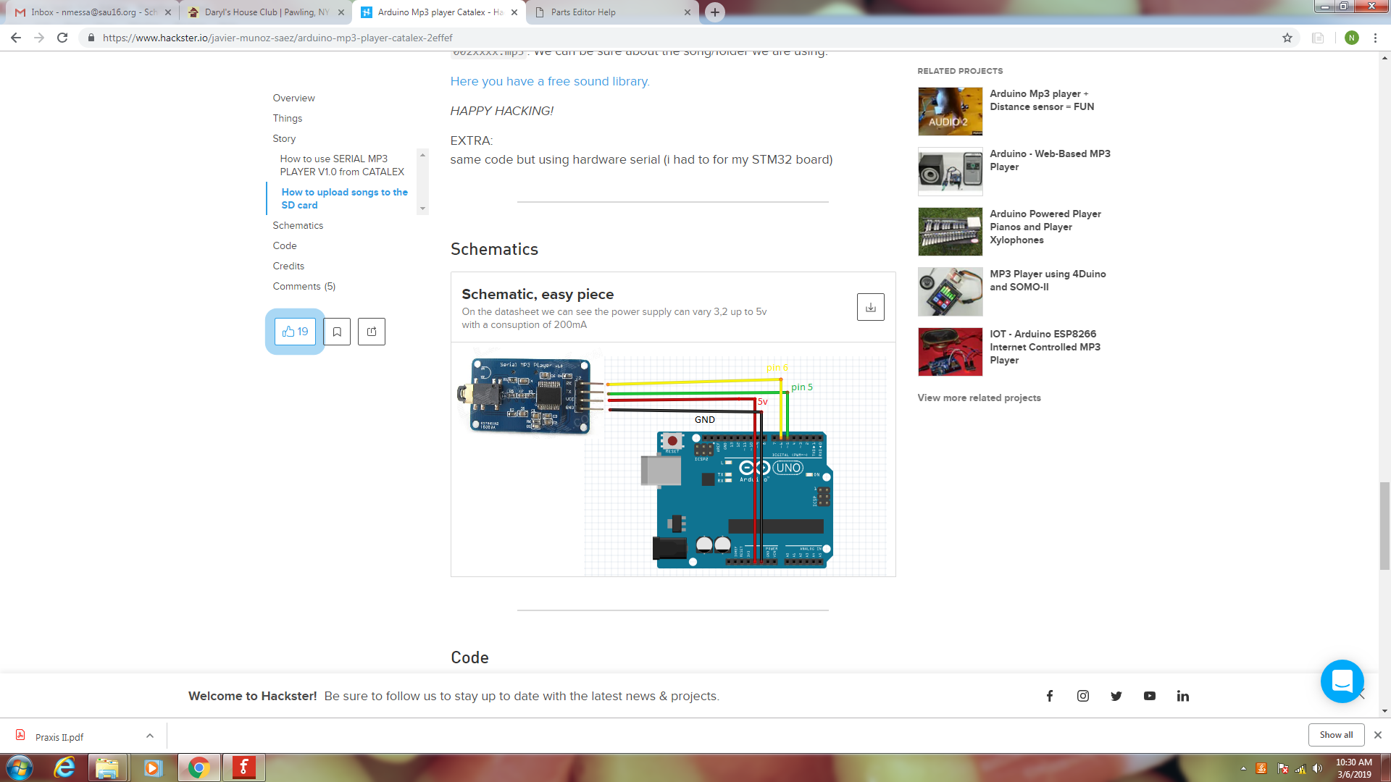

**The Code**

#include <SoftwareSerial.h>

#define ARDUINO_RX 5

#define ARDUINO_TX 6

SoftwareSerial mySerial(ARDUINO_RX, ARDUINO_TX);

static int8_t Send_buf[8] = {0} ;

#define CMD_PLAY_WITHVOLUME 0X22 //data is needed 0x7E 06 22 00 xx yy EF

//(xx volume)(yy number of song)

#define CMD_SEL_DEV 0X09

#define DEV_TF 0X02

void setup()

{

Serial.begin(9600);

mySerial.begin(9600);

delay(500);

sendCommand(CMD_SEL_DEV, DEV_TF);

delay(200);

}

void loop()

{

sendCommand(CMD_PLAY_WITHVOLUME, 0X1C07); //plays song 07 with volume 1C (28)

delay(290000); //wait 290 seconds for song to finish

}

void sendCommand(int8_t command, int16_t dat)

{

delay(20);

Send_buf[0] = 0x7e;

Send_buf[1] = 0xff;

Send_buf[2] = 0x06;

Send_buf[3] = command;

Send_buf[4] = 0x00;

Send_buf[5] = (int8_t)(dat >> 8);

Send_buf[6] = (int8_t)(dat);

Send_buf[7] = 0xef;

for(uint8_t i=0; i<8; i++)

{

mySerial.write(Send_buf[i]) ;

Serial.print(Send_buf[i],HEX);

}

Serial.println();

}